UDP SERVER COMMUNICATION USING SOCKET PROGRAMMING IN PYTHON

EXPT.NO: 3
AIM: To implement UDP client-server communication using socket programming in python.
ALGORITHM:
SERVER:
- Create a socket using socket.socket().
- Bind the socket to IP and port using bind().
- Receive message using recvfrom().
- Send response using sendto().
- Close connection.
CLIENT:
- Create a socket using socket.socket().
- Send message to server using sendto().
- Receive response using recfrom().
- Close connection.

CODE:
SERVER:
import socket

# Create UDP socket
sockfd = socket.socket(socket.AF_INET, socket.SOCK_DGRAM)
print("UDP Socket Created")

# Bind to localhost and port
sockfd.bind(("localhost", 55555))
print("Waiting for message...")

while True:
data, addr = sockfd.recvfrom(1024)
received_msg = data.decode()
print("Received message from", addr)
print("Message:", received_msg)

# Send reply back to client
sockfd.sendto(data, addr)
print("Message reply sent to client!")

choice = input("Do you want to continue (y or n)? ")
if choice.lower() == 'n':
break

sockfd.close()
print("Socket closed.")

CLIENT:
import socket

# Create UDP client socket
clientfd = socket.socket(socket.AF_INET, socket.SOCK_DGRAM)

# Define server address
server_address = ("localhost", 55555)

# Get user input
name = input("Enter your message: ")

# Send message to server
clientfd.sendto(name.encode(), server_address)

# Receive message from server
data, addr = clientfd.recvfrom(1024)
print("Message received from server:", data.decode())

# Close the socket
clientfd.close()

INPUT:
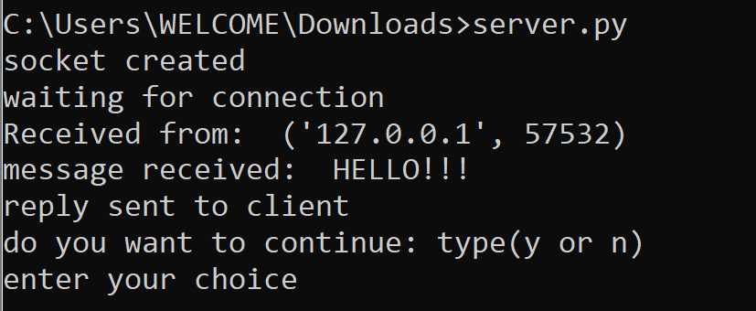

OUTPUT:
“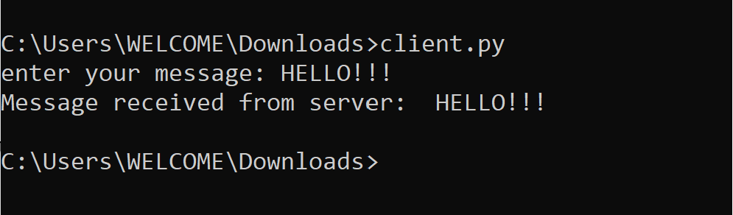
RESULT:
Thus, UDP client – server communication was successfully implemented using python.

